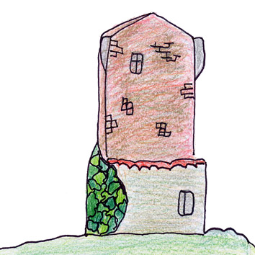 | 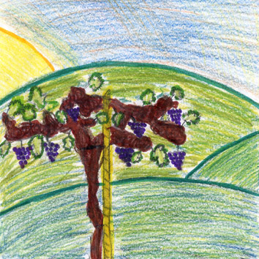
TORRE ALL’ISOLA  ISLAND TOWER  Ancient tower, used in Middle Ages to sight the enemy. | VITE – VINE  From grapes we obtain the famous Tuscan wine. Vine needs a little water and many sun.

