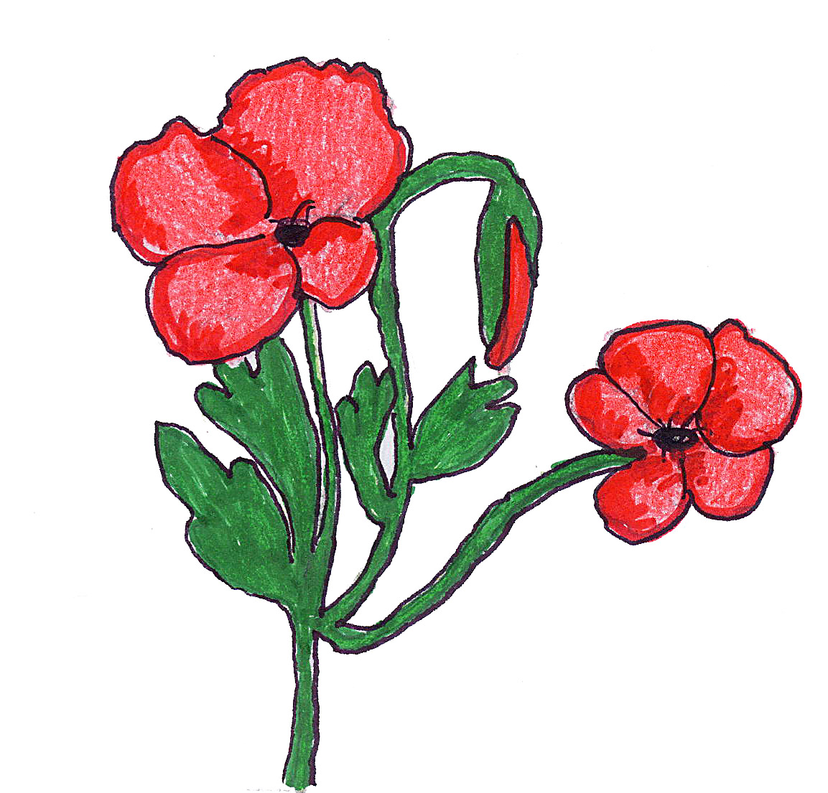 | 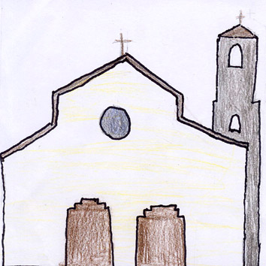
PAPAVERI – POPPY  The poppy is a wild red flower that you can find in Tuscan country during spring and summer. | PIEVE DI SAN LEOLINO  SAINT LEOLINO PARRISH  It’s the most ancient and the most important church in Rignano.
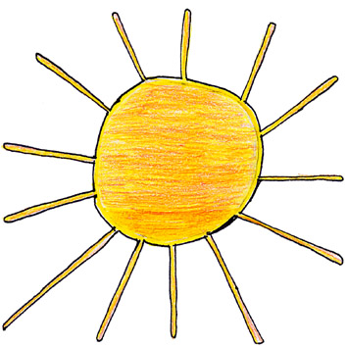 | 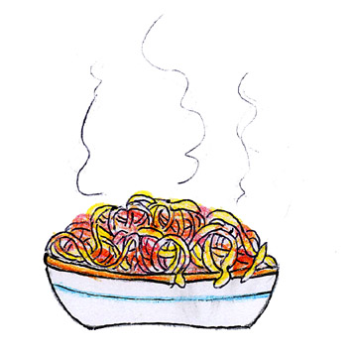
SOLE – SUN  Italian sun warms and shines for most year. | SPAGHETTI  Spaghetti are a kind of Italian pasta and they are very tasty with tomato sauce.  They look like threads.

