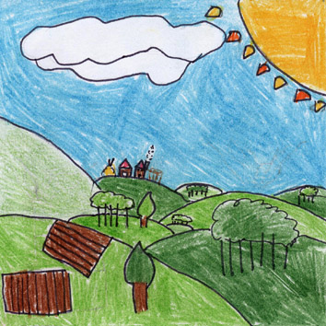 | 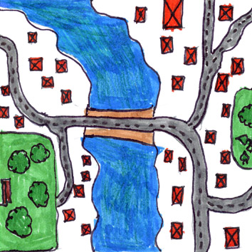
COLLINE – HILLS  In our area there are a lot of hills.  Vines and olives are cultivated on our hills. | FIUME ARNO – ARNO RIVER  Long and large river, which crosses Rignano village. Arno divides two districts: Rignano and Reggello.
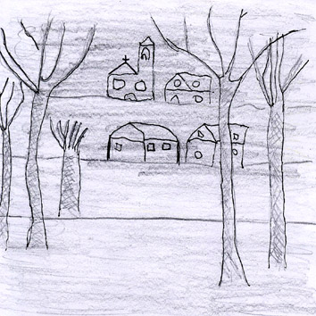 | 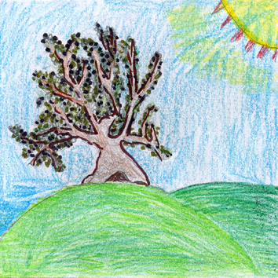
NEBBIA – FOG  We have often fog, because Rignano is in the Arno valley. | OLIVO – OLIVE  From olives we obtain a very good and famous oil to season foods.

