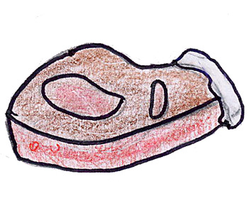 | 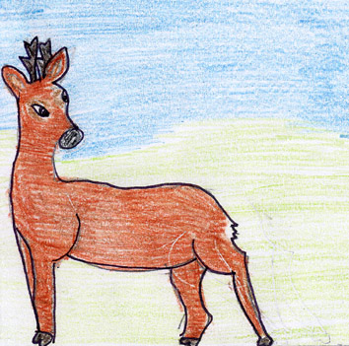
BISTECCA ALLA FIORENTINA  CHARCOAL GRILLED STEAK  Grilled steak, with the bone, very thick and little cooked. | CAPRIOLO - ROE BUCK  This animal is very widespreade in our woods. It lives in pack.
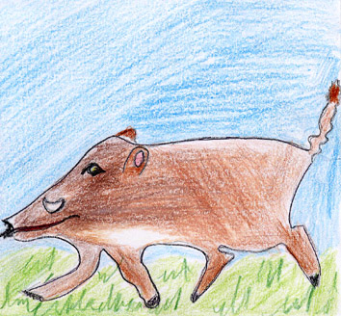 | 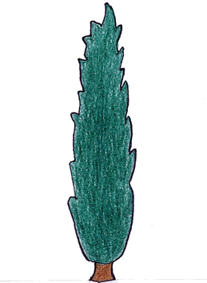
CINGHIALE - WILD BOAR  Wild animal, living in pack, very widespreade in our area. Its meat is very tasty. | CIPRESSO - CYPRESS  Typical tree of our hills.

