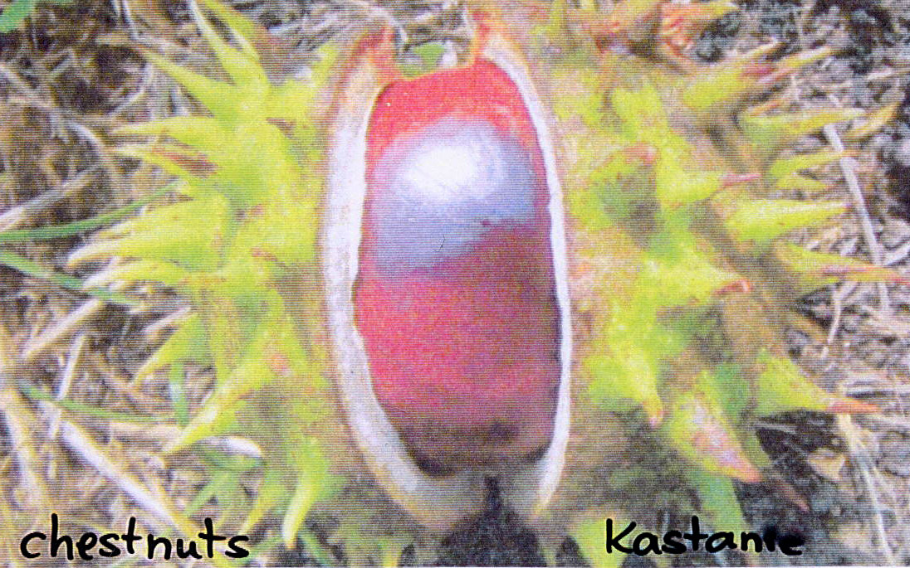  Bäume - Trees  We like the chestnut-tree, the oak and the beech-tree. In autumn we produce funny figures with the fruits (chestnuts, acorns, beech-nuts) of this trees. | 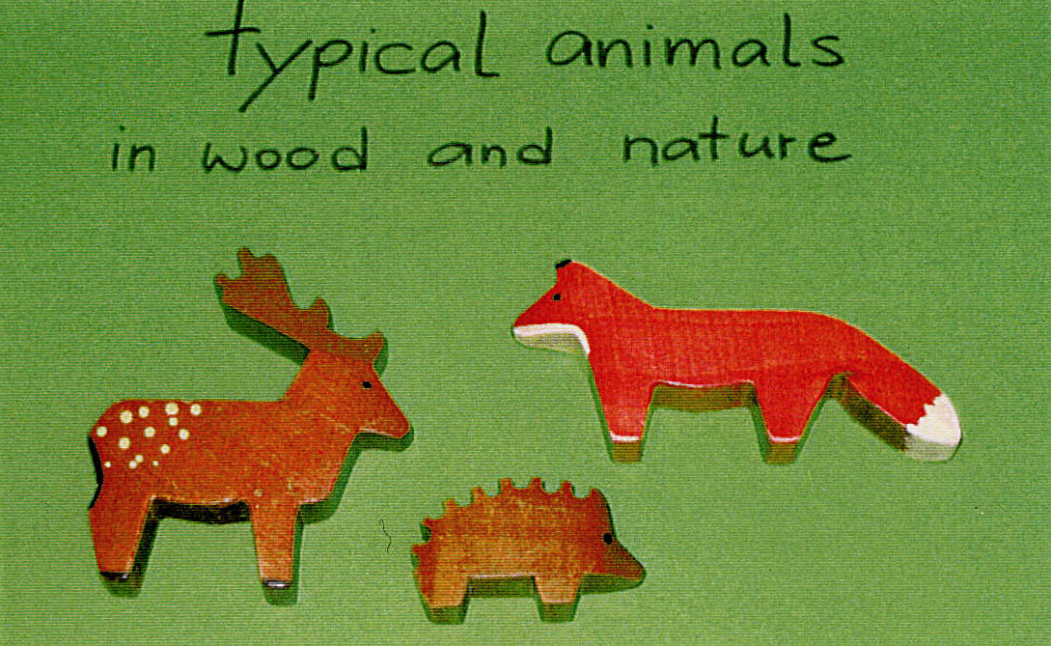  Tiere – Animals  In our nature and in the wood we discover roes and foxes, in the garden we can see the hedgehog sometimes.
Berlin is the German capital since 1990. The “Brandenburger Tor” is the special building in Berlin, because it is the symbol of the union in Germany (3.10.1990).  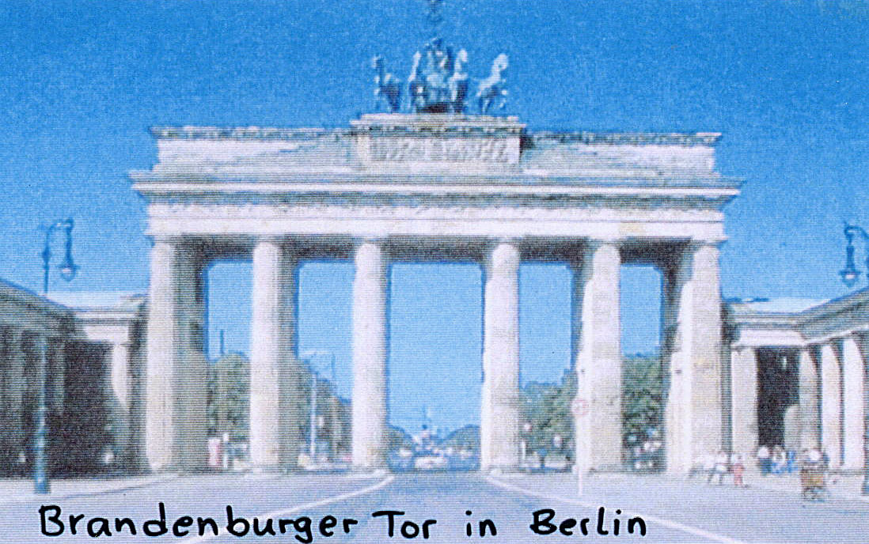 | 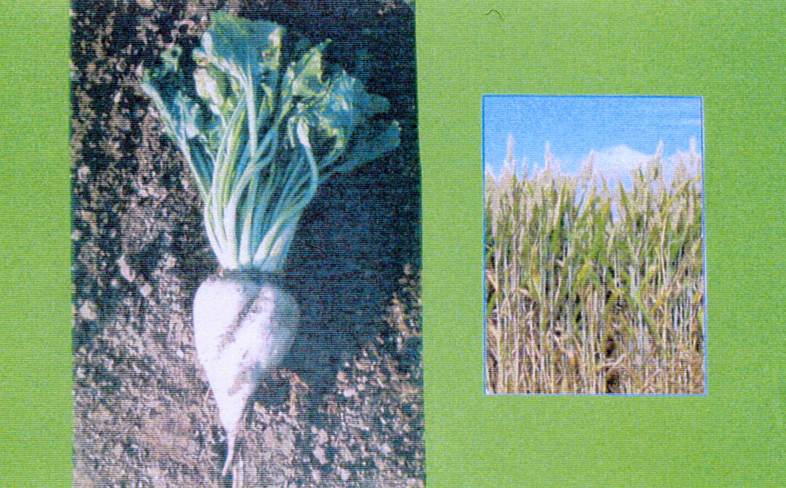  Landwirtschaft – Agriculture  In our region you can discover the cultivation of sugar-beet and wheat.

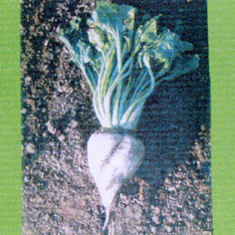
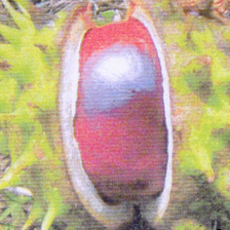
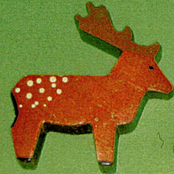
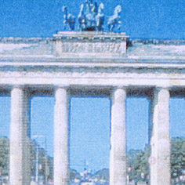

Obst – Fruit In our region the fruit-gathering of apples is very wide-spread. The apples will be sold or worked up to cider.  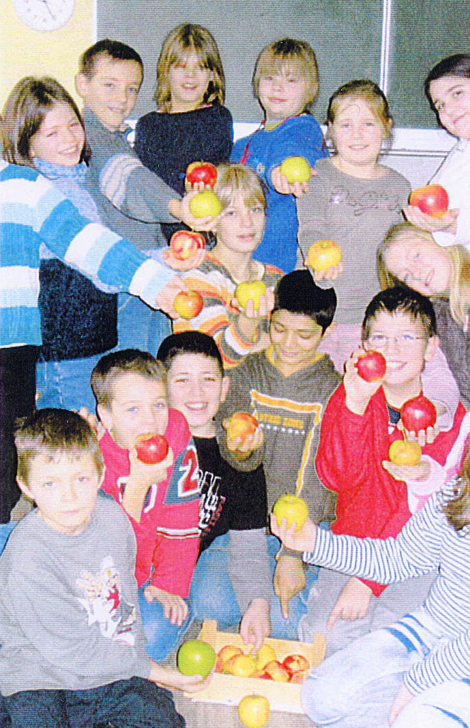 | 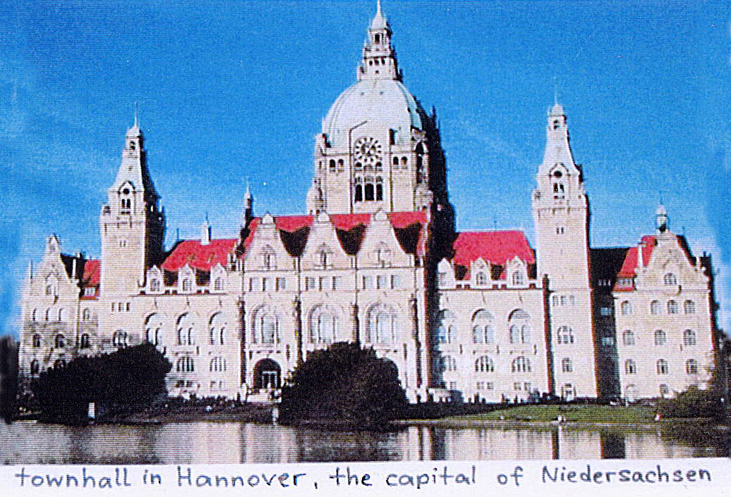  Niedersachsen is the federal country, where we live. It is one of sixteen federal countries in Germany. Hannover is the capital of Niedersachsen.
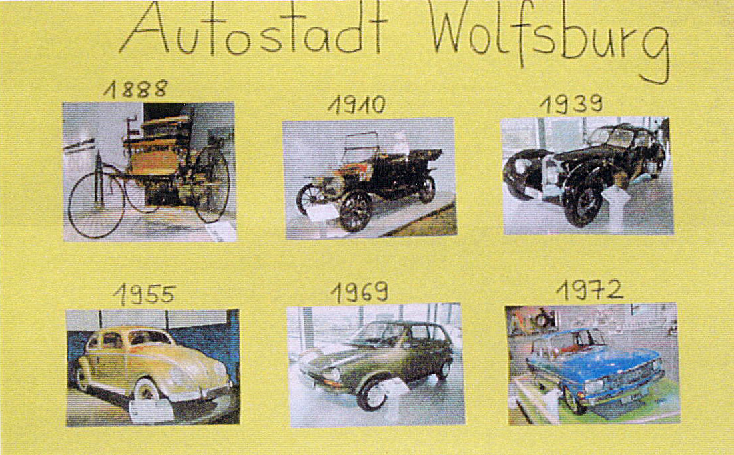  Industrie – Industry  Near our town in Wolfsburg you can visit a big motor industry. There you can discover a lot of things, especially in the “Autostadt Wolfsburg”, where children can do many experiments. | 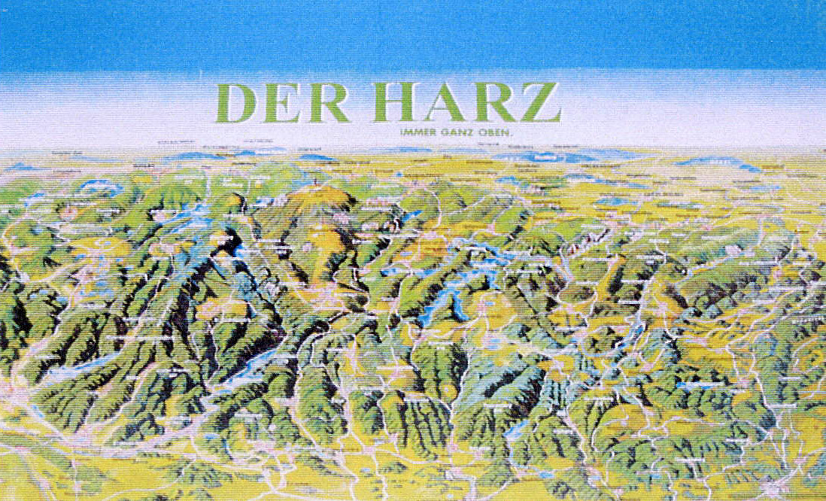  Der Hartz  You can discover highlands in the south of us: the “Harz”. A great part of it is situated in Niedersachsen. The highest mountain is the “Brocken”, he is situated in Sachsen-Anhalt, the neighbour federal country of Niedersachsen. The “Harz” is a popular excursion destination, especially in winter you can toboggan and ski.  It is an adventure to visit these highlands.

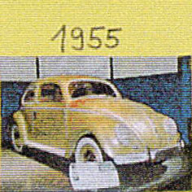
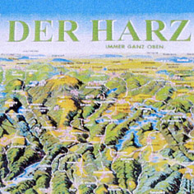
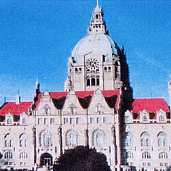
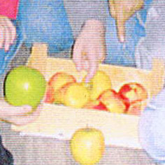

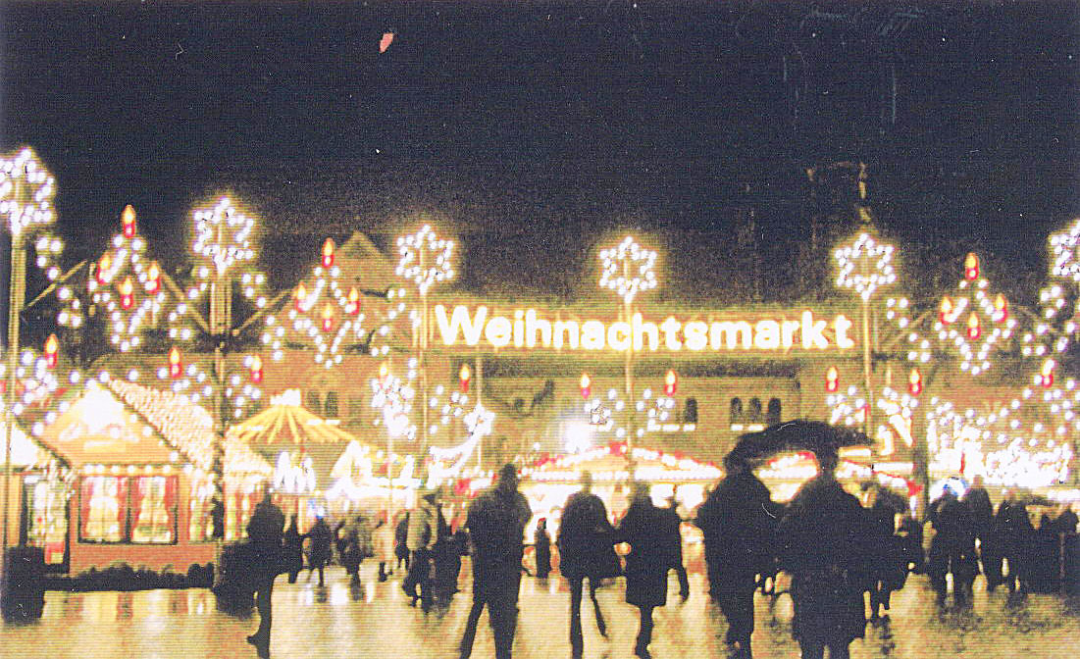  Weihnachtsmarkt – Christmas fair  During the Advent season you can se wonderful Christmas fairs in every town in Germany. Especially in Braunschweig (near our town) you find a nice Christmas fair. There you can discover a lot of lights in the evening. | 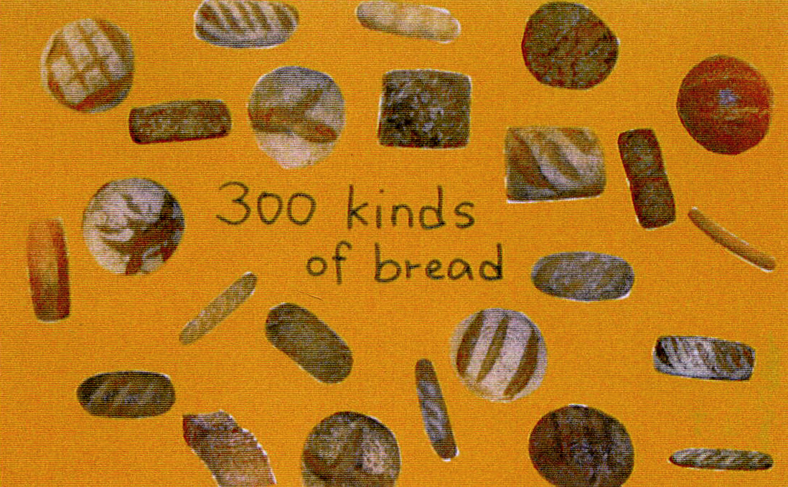  Brot – Bread  Germany is a country where you can find many different kinds of bread. In the end of summer we grind the grain and bake some bread in our school. This is delicious!
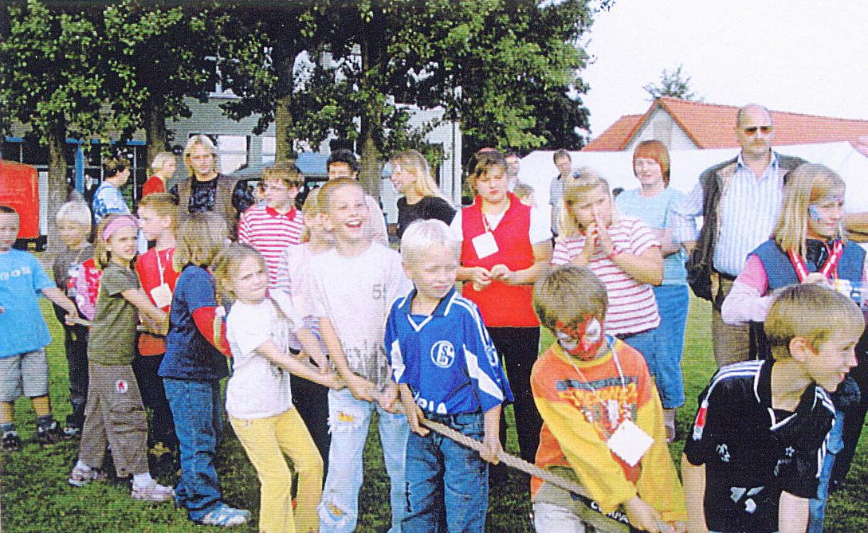  Schulfeste – School festivals  In our school we celebrate some festivals during the year. In summer we celebrate our summer festival and a sportsday, in autumn we celebrate Halloween, sometimes potato festivals or apple festivals, in winter we celebrate Advent and Christmas festivals, in February we celebrate carnival and so on. Come here and celebrate with us. | 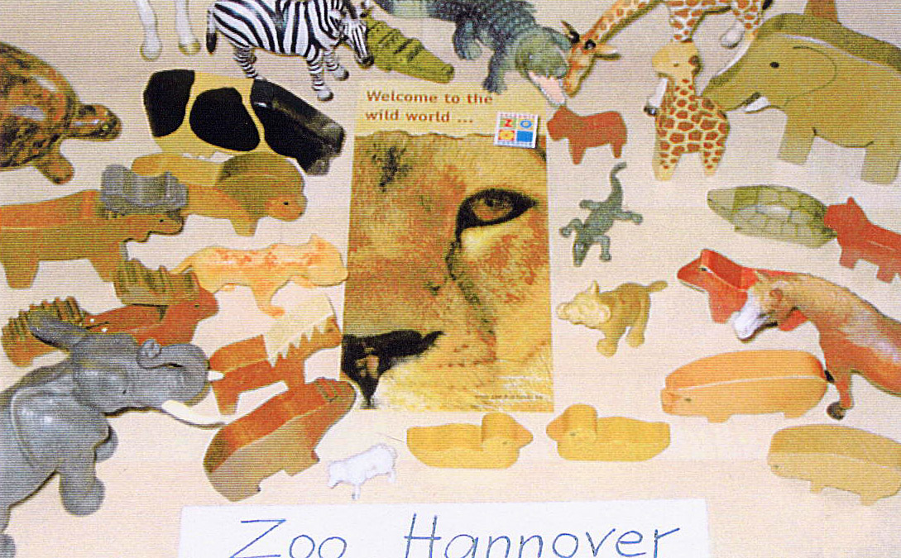  Zoo Hannover - We like to discover a multitude of animals in the “Zoo Hannover”. It’s a great pleasure for us to make excursions that way.
