Italy quiz n. 3 – “Il coccodrillo come fa?”
Listen to the song of the following link, then answer the questions https://www.youtube.com/watch?v=mHXlgHptunQ
- Which is the language af this song?
French Turkish | Italian Romanian | Polish

- Who sing this song?
A man | A woman | A child
- Which is the kind of music?
Classical music | Music for children | Pop music

- Which is the main character of the song?
a dog  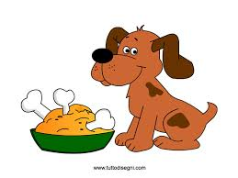 | a crocodile  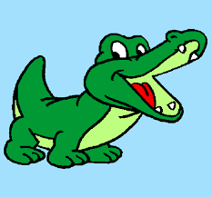 | a sheep  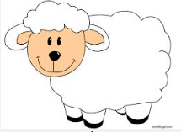

- Try to match the Italian words with the animals
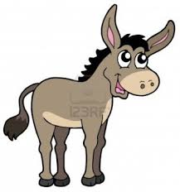 | cane | mucca | 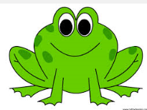
 | gatto | rana
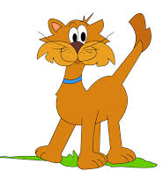 | asinello | pecora | 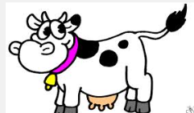
- Make a picture or a musicograma of this song.

