La rificolona – The “rificolona”

On September 6, Florence and its area celebrate the eve of the Birth of the Virgin Mary with the traditional procession of the Rificolone. This festival is so called remembering those women who came from the countryside into the city’s market square at dawn, wearing colorful costumes and lighting the way with lanterns. From this ancient custom, the festival, loved especially by children, was born, and the people light candles in multicolored paper lanterns called “rificolone”. There is a competition among the children about the most beautiful paper lantern, and this song is a joke about it. In fact it says: What a beautiful Rificolona! Mine has ribbons and yours has lice.

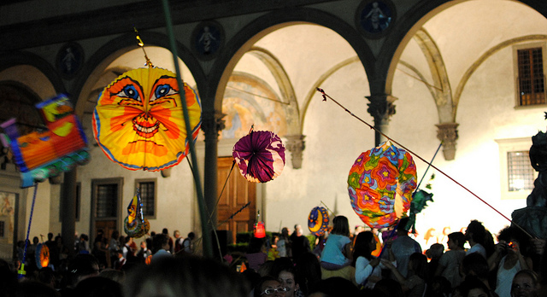

La rificolona
Ona ona ma che bella rificolona. (3 times)
La mia l'è coi fiocchi, la tua l'è coi pidocchi.
L'è più bella la mia di quella della zia.

